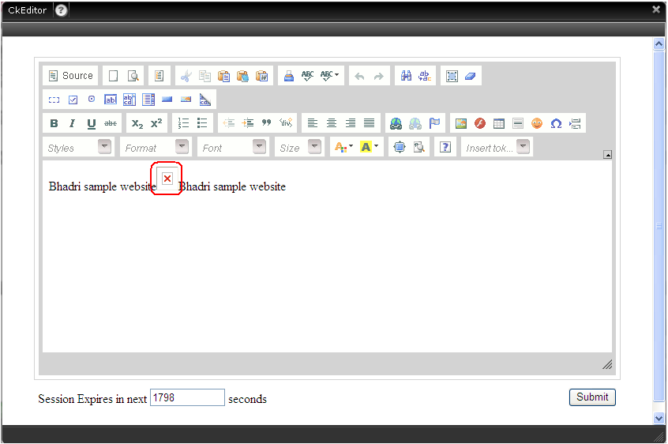

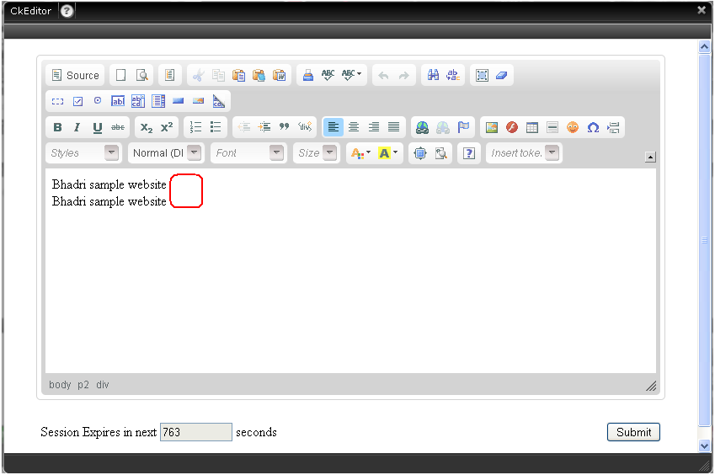

Image missing Icon is not displayed in CK Editor.

Steps to Re-Produce the Issue.

1. Place an Image Tag with wrong image name
2. Find that image missing icon is displayed in IE 8 but missing in Firefox

