Screen Shot 1:
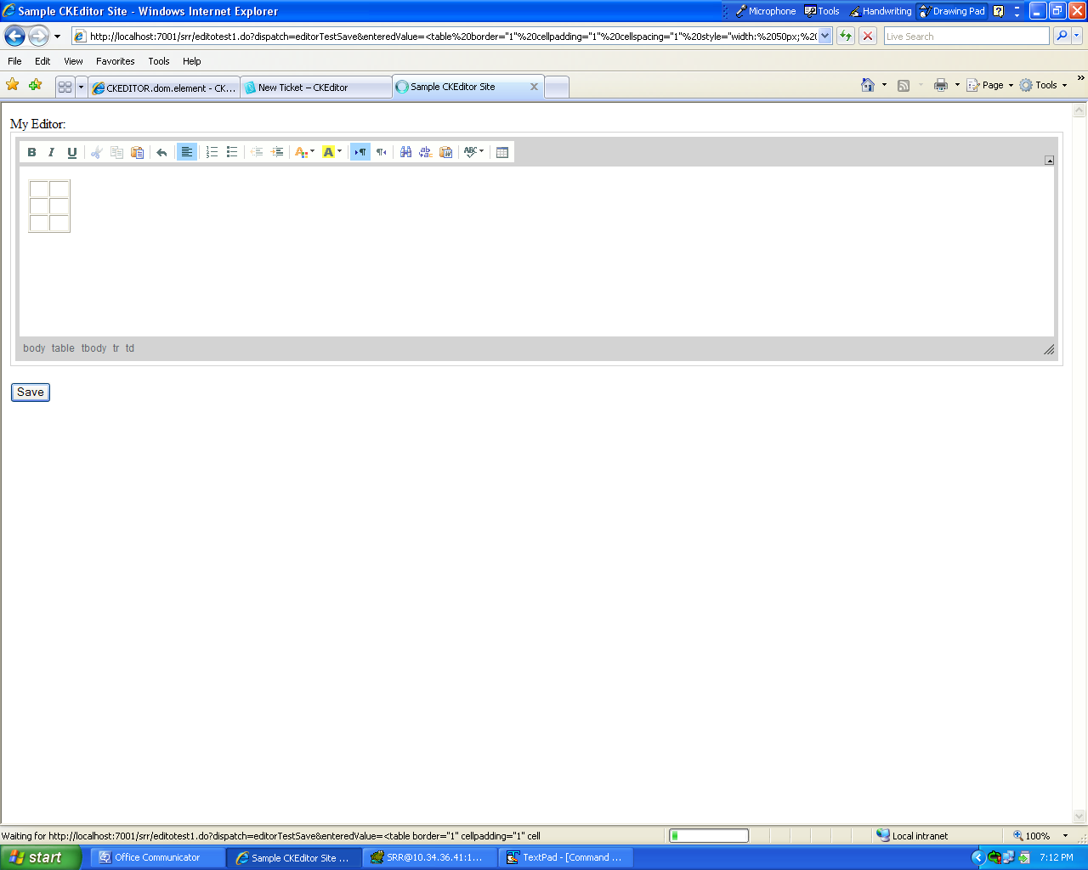

The users enters a table in the editor in the above screen shot

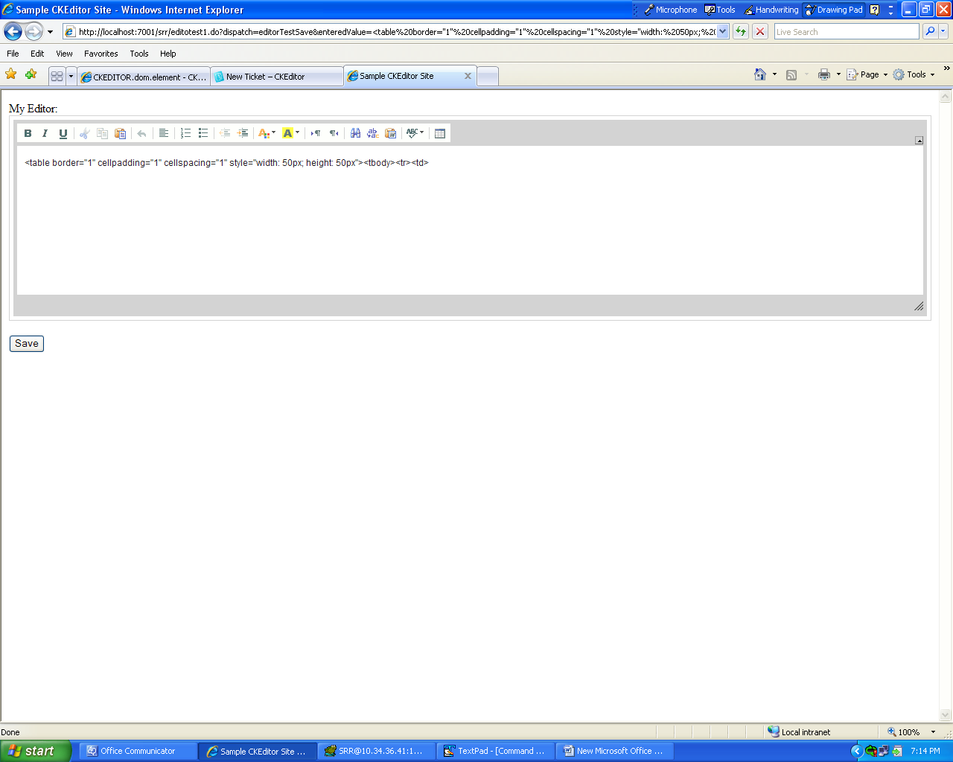

This is how the entered table is retrieved back from DB and displayed in the page. But I want this to be displayed as a table like in the screen shot 1.

My JSP Page:
<html>
<head>
<title>Sample CKEditor Site</title>
</head>
<body>

<html:form action="editotest1.do?dispatch=editorTestSave">

<div id="editor1">
<bean:write name="ConfigureReportForm" property="editortest"/>
</div>

<script type="text/javascript">
CKEDITOR.replace( 'editor1',
{
toolbar : 'MyToolbar'
});

function SaveData(){

var editor_data = CKEDITOR.instances.editor1.getData();
document.forms[0].action="editotest1.do?dispatch=editorTestSave&enteredValue=" +editor_data;
document.forms[0].submit();
}
</script>

<p>
<button id="myBtn" onclick="SaveData()">Save</button>
</p>
</html:form>
</body>
</html>

